**Group members**

Sayibu A. Gafaar

Justice Kofi Arma

John Hector

1. Exploring relationships

Hypothesis

H0: there are no significant relationships among amount paid, price, number of subscribers, number of reviews, number of lectures and content duration

H1: there are significant relationships among amount paid, price, number of subscribers, number of reviews, number of lectures and content duration.

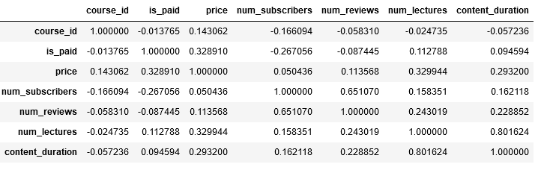

Figure 1: Correlation matrix

From the results in figure 1, it can be observed that amount paid has an inverse relationship with number of subscribers and number of reviews. This means that when amount paid increases the number of subscribers and number of reviews decreases. However, the remaining variables correlates positively with each other. This means an increase in any one of the variable will result in a corresponding increase in the research of the variables.

1. Categorisation of subject and course by programme of study

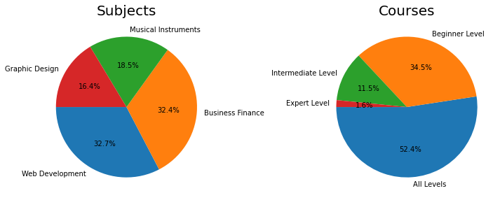

**Figure 2: Categorisation of course and subjects by level**

It can be observed in figure 2 that fewer people (16.4%) registered for graphic design compared with business finance (32.2%) and web design (32.7%) that had more people registering the programme. On the other hand, with regards to courses, only 1.6% got to the expert level compared to 34.5% for the beginner level.

1. The relationship between number of lectures and contends duration.

Hypothesis

H0: Number of lectures does not correlate with content duration.

The results in figure 3 shows a direct correlation between number of lectures and content duration. however, it can be seen that less lectures occur as the content duration increases.

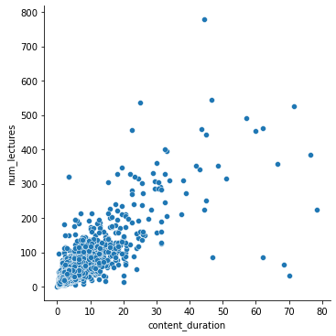

Figure 3: relationship between number of lecturers and content duration

On the contrary, the results in figure 4 shows that as price increases, content duration decreases. There are fewer contents are the prices increases. It implies an inverse relationship between price and content duration.

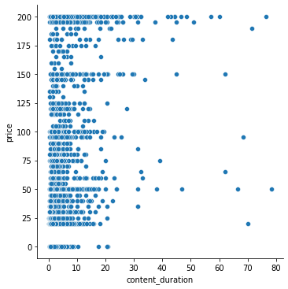

**Figure 4: relationship between price and content duration**

categorical plots to differentiate categorical variables

it can be observed that fewer pople are in the expert level compared to beginer level. the intermediate level was relatively higher than the expert level which recorded the least count

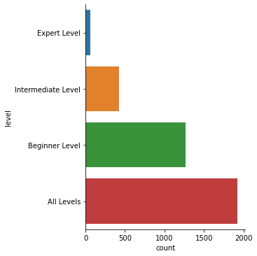

Figure 5: total number per level

It can be observed from figure 6 that the expert level has few people in all the four subjects. However, the numer of experts in the business subjects was relatively higher than the web development, graphic design and musical instruments combined. Similarly, the beginner level had higher number of subject counts compared to the expert level. it can be observed that web development and business finance had almost the same number of subject counts whilst graphic design had the least count.

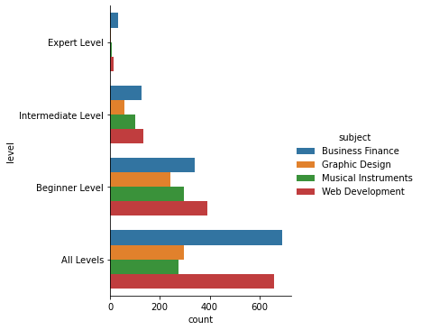

Figure 6: Comparing subjects by level

**Frequency of paid and nonpaid subjects**

For the paid staff, business finance had the highest count compared to graphic design that recorded the least count. Similarly, there where more nonpaid counts in the buniess finance than the rest of the four subjects.

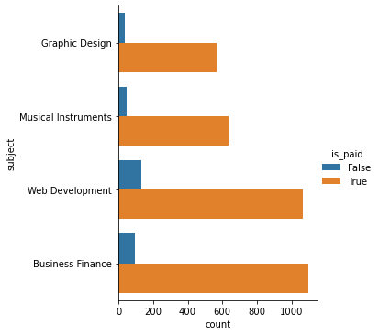

Figure 7: Frequency of paid and non_paid subjectes

Subjects by number of subscribers and level

It can be observd in figure 8 that web development has the least number of experts level compared to business finance that had the highest count of experts.s on the other hand, web development has more beginners than than music instrument, graphic design and business finance combined. The intermediate level was fairly low across all four sibjects.

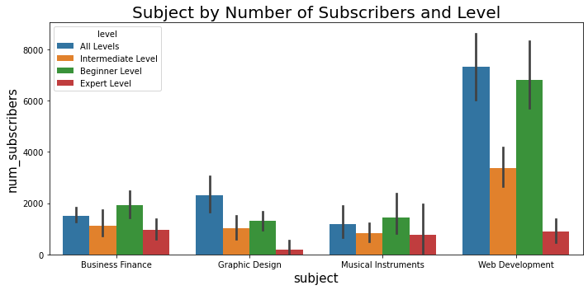

Figure 8: subject by number of subscribers by level

**Comparing group means**

It can be observed from figure 9 that the distribution of prices across graphic design, business finance and web development is negatively skewed and does not approach normality. This means that the prices for graphic design, business finance and web development is above the median price. On the other hand, the process for musical instruments is positively skewed and does not approach normality. It implies that most of the prices for musical instrument is below the median price.

